* Introduction:

An increasing amount of house builders have begun prefabricating parts of the houses in a controlled factory environment. A reason for house builders to move towards IHB is to counteract inefficiencies at the build site and increase competitiveness through for instance higher efficiency and quality and Manley.

Purpose:

\*Easy financing options

\*No uncertainty

\*No compromise

\*House as an investment

Problem Definition & Design Thinking:

\*Empathy Map

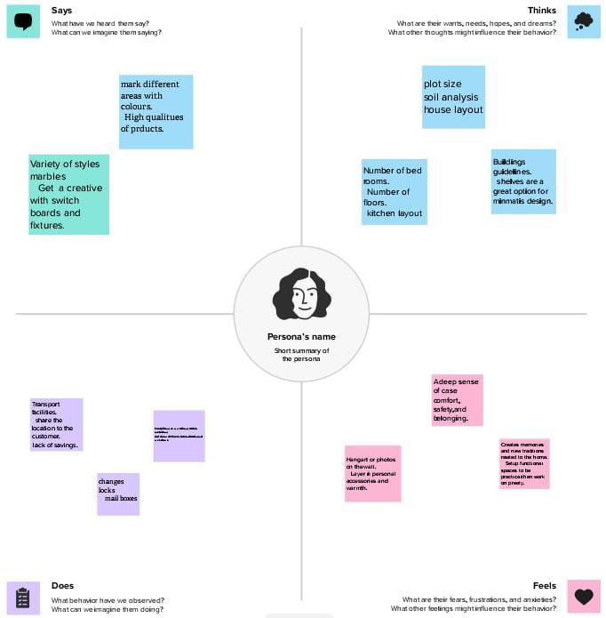

Ideation & Brainstorming Map:

\*Brainstorming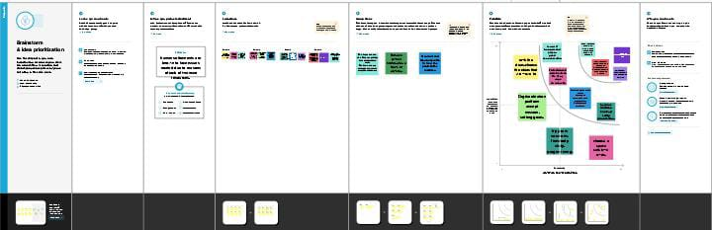

Result:

\*Profit & Loss:

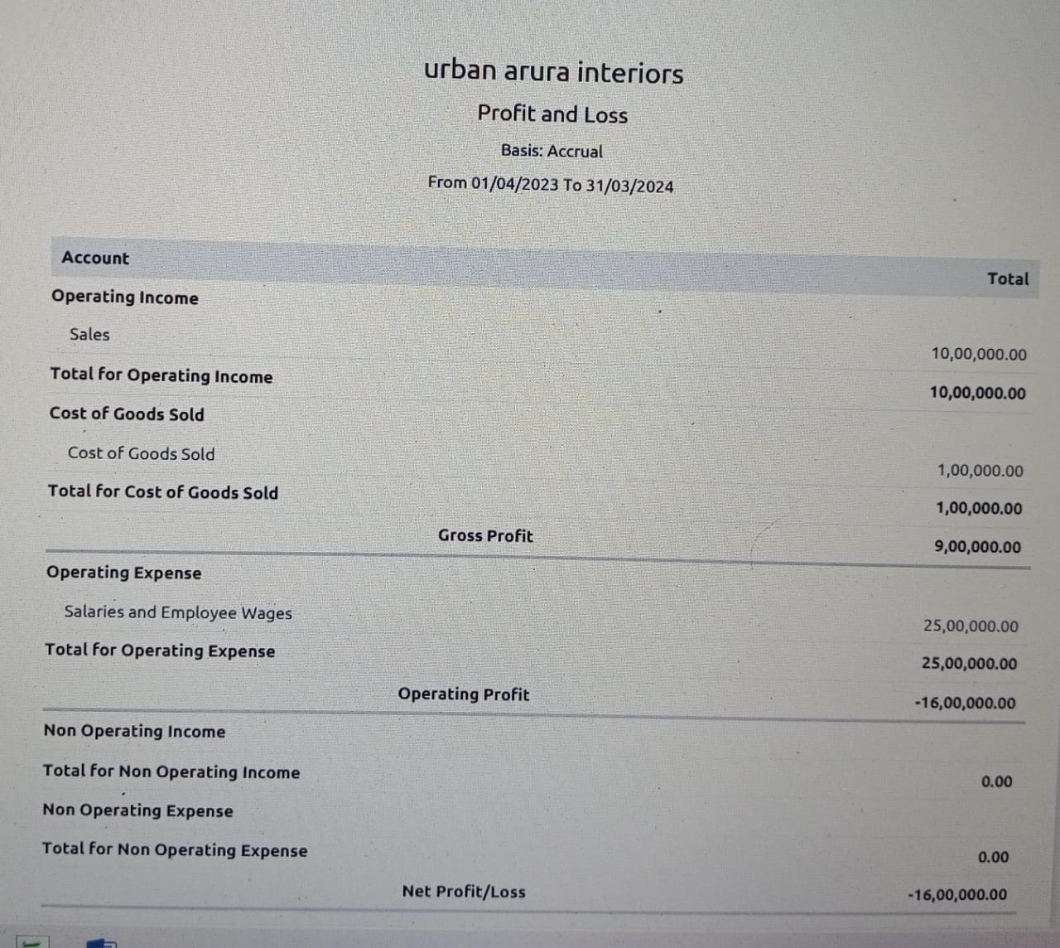

\*Balance Sheet

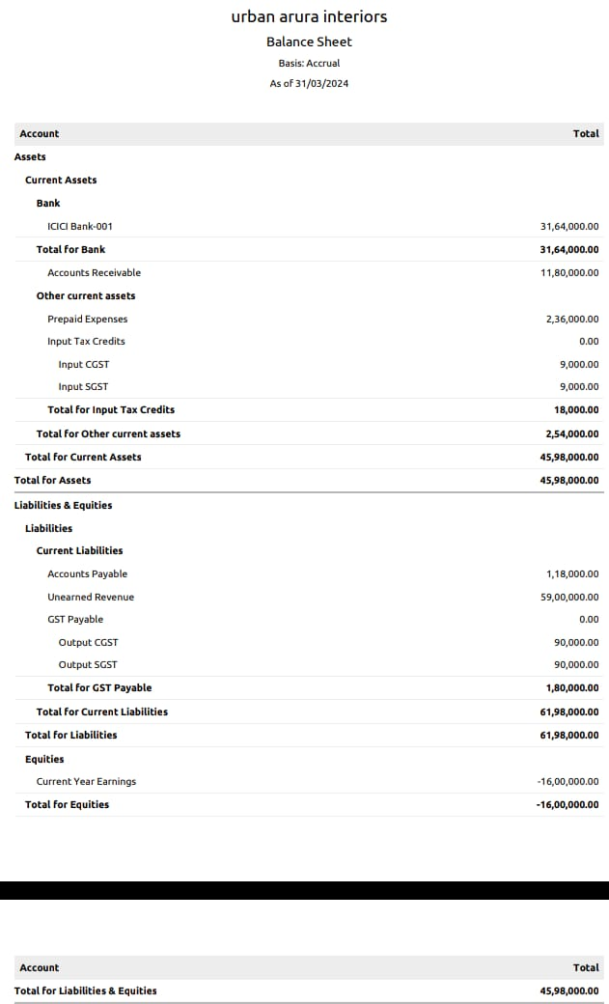

Advantages:

\*One Integrated Team Promotes One Mindset

\*Performance – Based Contract Steers Focus on Outcomes

\* Delivery Creates Budgetary Benefits

\*Innovation is Rewarded

\*Greates Value Goes to the Project

\*Target Value Delivery Creates Budgetary Benefits

Disadvantages:

\*Psycial barriers-especially in constructions without windows.

\*In many cases, too small amount of day lights.

\*No equity growth or store of value.

\*Less predictable housing expense.

\*No experience in housing lending expert for short term loan.

\*Costly seccure of loan.

Application:

370A1,North Car Street,Coimbatore 626 117.

TamilNadu,

India,

9876543579.

Conclusion:

A conclusion is the final piece of writing in a research paper, essay, or article that summarizes the entire work. Balance sheet of the amount Rs.1600000 of the balance amount. Profit & Loss amount cost of sold goods of Rs.100000 and total amount of Rs.1600000.

Future Scope:

After finishing the B.com Degree start a business of house integration and try to a best house builders to condent of the dream house are real life.

Appretix: 